EMBARGOED UNTIL 10TH MAY 2022
Bowers & Wilkins announces major Custom Installation product debuts at ISE 2022

Integrated Systems Europe sees debuts of two new in-wall subwoofers and a pair of powerful, smart amplifiers.
ISE 2022 sees the global launch of the CDA-2HD and CDA-4D DSP amplifiers, and the ISW-6 and ISW-8 inwall subwoofers. The Sound United stand at the Barcelona event will also showcase other Bowers & Wilkins Integrated Solutions products.
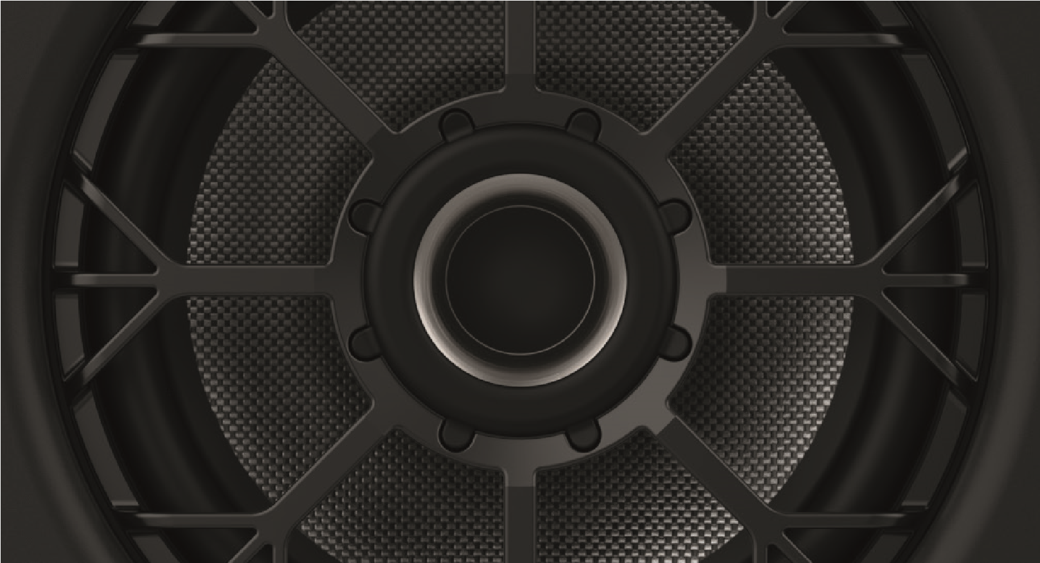
Bowers & Wilkins is proud to announce that Integrated Systems Europe 2022 will see the launch of four exciting new products. Visitors to Fira Barcelona Gran Via between the 10th and 14th May 2022, will be the first people to see the new Bowers & Wilkins CDA-2HD and CDA-4D DSP amplifiers, and the ISW-6 and ISW8 in-wall subwoofers.
The CDA-2HD is a high-power distribution amplifier with embedded DSP that allows optimization of a wide range of products and dynamic EQ for Bowers & Wilkins subwoofers. It boasts two channels of 500 watts each, within a half-rack width 2U design.
The CDA-4D is a compact distribution amplifier with embedded DSP that allows optimization of a wide range of products and dynamic EQ for Bowers & Wilkins subwoofers. It boasts four channels of 125 watts each, and its 1U design delivers high-performance from minimum rack space.
ISW-8 is Bowers & Wilkins flagship in-wall subwoofer; it delivers class-leading subwoofer performance for completely installed applications. It’s a no-compromise design for when power and performance are key, but has a thin profile that allows it to fi t into a 2in x 4in stud wall.
Finally, ISW-6 is a discreet, compact and versatile custom installation subwoofer, with twin ‘racetrack’ drivers arranged in a force-cancelling configuration. It is designed to work primarily with Bowers & Wilkins CI300 and CI600 speakers.
Prices and availability:
CDA-2HD | $2,500 | October 2022
CDA-4D | $2,000 | October 2022
ISW-8 | $2,500 | October 2022
ISW-6 | $1,300 | October 2022
ISW-6 Retro Fit Grille | $180 | October 2022
Bowers & Wilkins can be found at International Systems Europe, which runs from the 10th and 14th May 2022 at Fira Barcelona Gran Via, Barcelona, Spain.
About Bowers & Wilkins
Bowers & Wilkins, founded in the U.K. in 1966, has been at the forefront of high-performance audio technology for more than 50 years. It designs and manufactures precision home speakers, headphones,
custom installation and performance car audio products that set new standards for innovation and sound quality, earning countless awards and accolades from the world’s leading recording studios and musicians. Bowers & Wilkins’ reputation is based on the unwavering pursuit of the best possible sound and an unsurpassable music listening experience. Bowers & Wilkins joined the Sound United LLC family of brands in 2020. Learn more at www.bowerswilkins.com.
CDA-2HD | CDA-4D
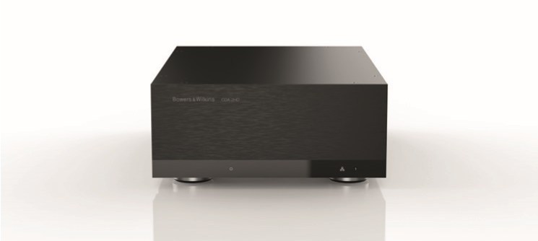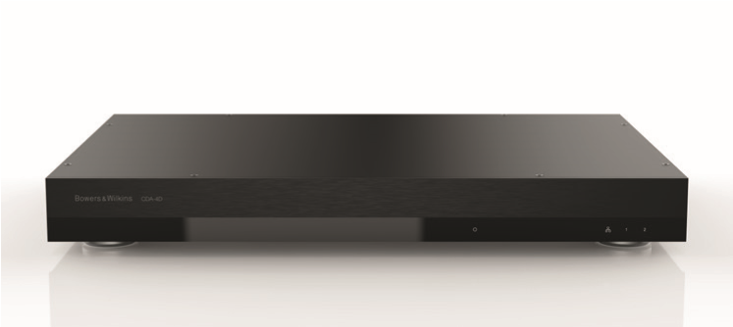
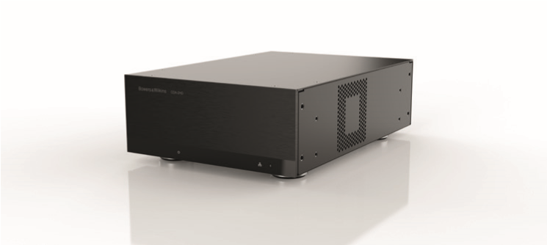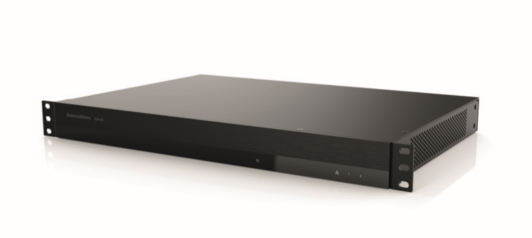

ISW-8 | ISW-6
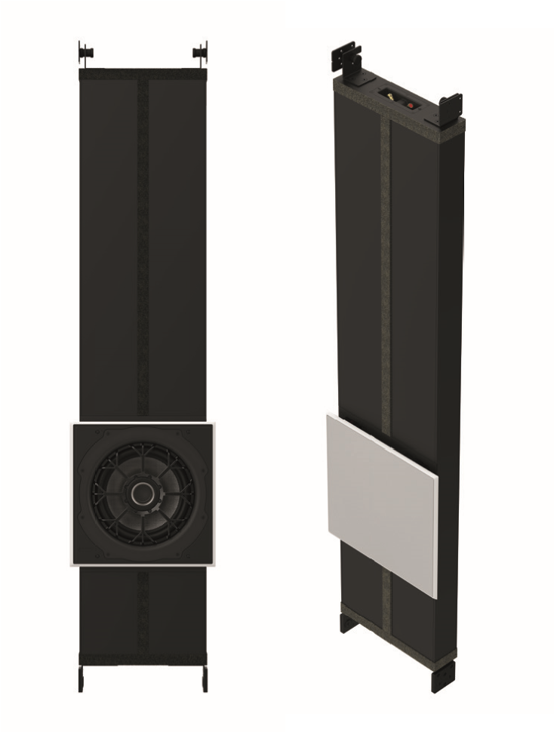
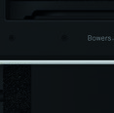
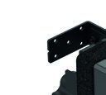
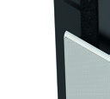
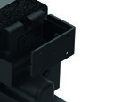
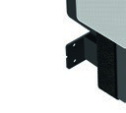
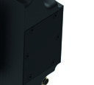
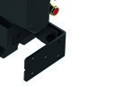
For more information, please contact:
Lucette Nicoll / John Nicoll
Nicoll Public Relations
617-479-9906 john@nicollpr.com
781-789-6000 lucette@nicollpr.com
Copyright © B&W Group Ltd. E&OE.

